The Sheep Market: Two Cents Worth

Aaron Koblin
Design|Media Arts
UCLA 2006
Thesis Document
The Sheep Market

- Introduction
  - The setting
  - Kempelen’s Mechanical Chess Machine
  - The sheep Market
    - Inspiration
    - Project overview
  - Thesis objective
- Background
  - Elements of sheepology
    - Sheep Culture
      - The Good Shepherd
      - Dolly
      - Le Petit Prince
    - Sheep in Commerce and Industry
      - The British agricultural revolution
      - Industrial revolution
      - wool processing
  - Assembly line production
  - Marx
    - Alienation
    - Commodity fetishism
    - Beyond Marx
  - Mind-machines
    - Amazon’s Mechanical Turk
    - Kurzweil vs Diamond
- The Sheep Market: An analysis
  - Project
    - Opening store
    - Sheep in Turk’s Clothing
    - Presentation
    - Selling sheep
    - Response (Public Outcry)
    - Shepherding
- Art and information
  - Aesthetics of governance
  - Data that Moves
- Conclusion

1. Introduction

1.1. The Setting

“Commerce dictates, culture follows”

Early in November 2005 there was buzz in the tech-business world about a new service which had “great potential for tapping into the wisdom of crowds.” Upon further investigation, the service revealed that it intended to provide “…access to a vast network of human intelligence with the efficiencies and cost-effectiveness of computers.”

Amazon's Mechanical Turk (MTurk) is a system for harnessing the power of distributed human intelligence. Intended for corporate use, MTurk is based upon the notion that certain tasks are simple for people and difficult for computers. The website explains to potential workers that they can “…complete simple tasks that people do better than computers. And, get paid for it. Choose from thousands of tasks, control when you work, and decide how much you earn.” The system is comprised of an automated work force in which computer and human processing are intertwined. Aware only of their simple task, the workers remain alienated from the larger processes they are contributing to. This organizational format, typically implemented by corporations, tends to yield highly organized, efficient results for the purposes of targeted economic gain.

Amazon’s “artificial artificial intelligence” service clearly stated its desire to establish a framework for the utilization of people as computers. In the same form that a computer scientist would request a piece of information from a database, applications could now be developed to retrieve information from human brains. Amazon was already using the system for cataloging where barcode information was damaged or unreadable. They had realized that it was often easy for people to recognize the name and artist of a compact disc despite the task being very difficult for computers which have less means to decode the stylized typography and placement. The practical applications of this sort of system were immediately apparent and the progression of technology and business made the creation of such a system seem like the next logical implementation of post-industrialized labor management in the globalized economy.

1.2. Kempelen’s Mechanical Chess Machine

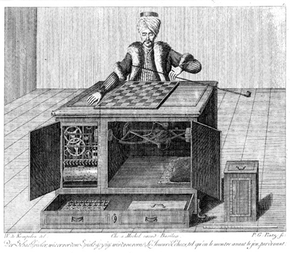

The inspiration for Amazon's “Mechanical Turk” comes from an invention of the same name by the Hungarian nobleman Wolfgang von Kempelen, who, in 1769, became famous in Europe for having created a mechanized chess player from wood and gears. The act was in reality a fraud. The machine was controlled by a human chess player cleverly concealed within the wood case.

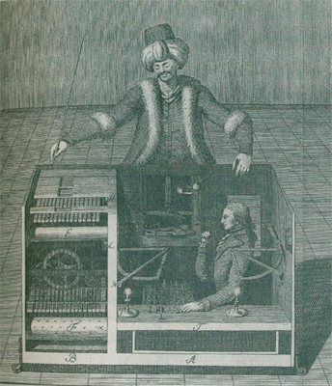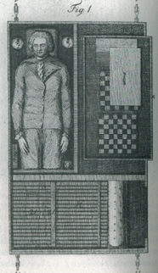
The Mechanical Turk Inner Workings

The Mechanical Turk was a huge success and encountered a host of historical figures including Benjamin Franklin, Catherine the Great, Napoleon Bonaparte, Charles Babbage, and Edgar Allen Poe. As explained in Tom Standage’s book, “The Turk: The life and Times of the Famous Eighteenth-Century Chess-Playing Machine,” the entire endeavor was quite complex, including an elaborate system of gears and controls, doors to conceal and reveal, and a convincing performance to tie everything together.
“Stepping forward to address the audience, Kempelen explained that before demonstrating his automaton, he would display the inner workings. He reached into his pockets and produced a set of keys… Kempelen opened this door to reveal an elaborate mechanism of densely packed wheels, cogs, levers, and clockwork machinery…. He unlocked and opened another door immediately behind the machinery… [and] held a burning candle behind the cabinet in such a way that its flickering light was just visible to the audience through intricate clockwork. “

In this spirit, Amazon Web Services decided to name their system “The Mechanical Turk,” as a reference, and perhaps homage, to the system which incorporated people to be viewed as machines.

1.3. The Sheep Market

1.3.1. Inspiration

Constantly in a schizophrenic battle between my own luddite philosophical tendencies and an overwhelmingly nerdy curiosity in all technological tools, I had a strong, although ambiguously confused, reaction to the service. First and foremost I was struck by the naming of the system and the connotations of people attempting to guise their actions as coming from something other than themselves. Additionally, the idealistic portrayal of a system which seemed to achieve a new level of depersonalization and exploitation in the workplace seemed more than slightly unnerving. Immediately, questions about the potentially far-flung uses, and correspondingly disparate outcomes that might result from using such a tool excitedly sprung into mind. After a few initial experiments, it became clear that a brave new world was begging to form, and using the Mechanical Turk one could command the actions of thousands of individuals to do just about anything, or so it seemed, and thus, my project The Sheep Market was born.

1.3.2. Project Overview

The Sheep Market, is a web-based artwork that appropriates the MTurk system to implicate thousands of workers in the creation of a massive database of drawings. From one simple request, submitted to the MTurk system as a 'HIT' or Human Intelligence Task, workers create their version of “a sheep facing to the left” using simple drawing tools. The artist responsible for each drawing receives a payment of two cents for their labor.
The specific technology and system being implemented by the Mechanical Turk is new, but the ideology of bureaucratized systematized human labor is firmly established and has been maturing rapidly since the industrial revolution. Marx, Engels, and other early socialists established the foundations for discussing the cultural and political ramifications of such systems. Their discussions of the alienating impact of massive distributed employment facilities have lead to more contemporary debates incorporating issues of cultural objectification and intellectual property as discussed by theorists such as Maurizio Lazzarato.
The inspiration for The Sheep Market project stems from the urge to cast a light on the human role of creativity expressed by workers in the system, while explicitly calling attention to the massive and insignificant role each plays as part of a whole.

1.4. Thesis Objective

This thesis exploration will investigate the context of The Sheep
Market art project. The analysis will revolve around key questions raised by the project such as; Are the results of alienation apparent in massively bureaucratized labor systems? Is there/what is the role of creativity in such a system? And, who is responsible for maintaining culture as these systems permeate our lives. This paper will explore the discourse surrounding commoditization of human labor, the connotations of sheep, and the techniques of visualizing governance within the realm of media art.

2. Background


From the first 10,000 submissions, only two were directly questioning the meaning of the task. The answer to this question is multifaceted. This portion of the thesis introduces the facts and theories which inspired and influenced the Sheep Market project.

2.1. Elements of Sheepology

Sheep have played an important role in the development of civilization. One of the first animals to be domesticated and used for utility and consumption, the sheep has maintained a relatively central role throughout social evolution. Through analysis of the role of sheep within culture and industry one can contextualize and explore the facts and stories central to the subject of the Sheep Market.

2.1.1. Sheep Culture

“Four legs good, two legs bad!” In the book Animal Farm, George Orwell used sheep to represent followers. This decision was not arbitrary, and the obedience of sheep is a quality the animal has been noted by throughout history. The role of sheep in culture has changed over time, but the relationship to humans is understandable for both scientific and sociological reasons. From China, to the Fertile Crescent, the sheep has symbolic and cultural roles in a variety of international contexts.

2.1.1.1. The Good Shepherd

Beginning with the Old Testament there are numerous biblical references to sheep and shepherds. Many heroic characters in western religious texts are shepherds, or are referred to as shepherds, from the prophet Amos, King David and Moses, to Abraham, and most of god’s “chosen people.” The metaphor of the shepherd extends into the Roman Catholic Church and the Church of England, where bishops adorn a shepherds crook within their insignia, and Jesus is often referred to directly as the Good Shepherd.

“The good shepherd gives His life for the sheep. But a hireling, he who is not the shepherd…, sees the wolf coming and leaves the sheep and flees; and the wolf catches the sheep and scatters them. The hireling flees because he is a hireling and does not care about the sheep. I am the good shepherd; and I know My sheep, and am known by My own.”

The idea of the shepherd as a leader of peoples may clearly be at the root of the common titling of human followers as sheep. A term often glorified in biblical reference, ‘sheep’ has now become often associated with a negative connotation. This negative association likely comes from the unflattering picture that sheep are known to be easily lead astray, extremely vulnerable, and usually destined to be slaughtered for consumption. It is this portrayal of humans as sheep that has been primarily referenced in countless writings of fiction, theory and philosophy.

2.1.1.2. Dolly

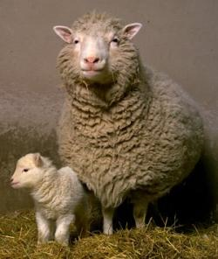
Dolly the Sheep

On July 5th, 1996 Dolly the sheep was introduced to the world through a process known as somatic cell nuclear transfer, or cloning. Dolly, named after Dolly Parton in reference to being derived via the material extracted from a mammary gland, was short-lived due to illness, but is otherwise considered to be the first successful mammalian clone. The presence of Dolly became known quickly and she brought with her a barrage of questions and anxieties. In addition to the genetic concerns about safety and regulation, a gamut of moral questions surfaced from discussions about the implied trajectory of the science of cloning. In some sense, Dolly became a symbol for genetic tampering and the potentially dystopic human modification that science was fringing upon. To many, the heterogeneous societies of science fiction novels could be seen beginning in this act, a brave new world indeed.

2.1.1.3. Le Petit Prince
“’If you please--draw me a sheep . . .’
When a mystery is too overpowering, one dare not disobey. Absurd as it might seem to me, a thousand miles from any human habitation and in danger of death, I took out of my pocket a sheet of paper and my fountain-pen. But then I remembered how my studies had been concentrated on geography, history, arithmetic and grammar, and I told the little chap (a little crossly, too) that I did not know how to draw. He answered me:
‘That doesn't matter. Draw me a sheep . . .’”
-Le Petit Prince
Le Petit Prince, by Antoine de Saint-Exupery originally published in 1943, is one piece of fiction which subtly incorporates images of sheep as a pivotal point in the narrative. A tale about life and the truths that are often more apparent to children than adults, Le Petit Prince discusses perception, creativity, and purpose. In the story, the narrator comes upon a prince in the middle of the desert and is asked to draw a sheep. The narrator makes some attempts, each of which is dismissed by the Prince.
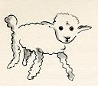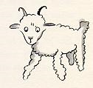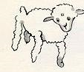
Ultimately, the narrator draws a box with holes and explains that the sheep is inside the box, finally the prince is satisfied.

The novel subtly references the sheep in a commentary about the scientific approach to explanation. As the narrator struggles to use relatively formal techniques to render the visible image of a sheep, the prince seems to suggest that there could be different goals and objectives guiding his process. Ultimately, the image itself contains no literal sheep at all, but simply a view from ‘outside the box’.

2.1.2. Sheep in Commerce and Industry

From the earliest experimentations with animal husbandry, the sheep became a central component of commerce and industry. Although the main use of sheep in the marketplace changed greatly, it has remained of high value. Used for wool, meat and milk, and with innate tendencies such as flocking rendering maintenance relatively simple, the interest in sheep farming is clearly understandable.

2.1.2.1. The British Agricultural Revolution

In the mid 18th century, Robert Bakewell devised a system of selective breeding in which animals could be organized based on specific traits and be bred accordingly. Bakewell’s “New Leicester” sheep is the first known example of this selective breeding process taking hold in practice. Additionally, Bakewell organized “the Dishley Society” in order to maintain purity of the breed through specific rules, and subsequently he created a monopoly over the breed. This practice is argued by many to be one of the primary factors leading to the agricultural revolution, and a major influence on the beginnings of the industrial revolution.
The result of Bakewell’s selective breeding and inbreeding techniques was the reduction of genetic diversity and the breeding of a more uniform and consistent sheep. This process followed through to other livestock, and is fundamentally the same technique used today.

2.1.2.2. The Industrial Revolution and Wool

Following a similar trajectory to that motivating Bakewell’s processes, the Industrial Revolution brought along methods to decrease diversity and increase efficiency in other aspects of commerce. In England, the seasonal nature of agriculture meant substantial free time during portions of the year for a number of peasants. This extra time was utilized by many who were able to setup shop within their homes. This system, known as the “cottage industry” was primarily utilized for the spinning of sheep’s wool. The cottage industry, which would employ entire families from their houses, has notable similarities to the Mechanical Turk, such as employing people for spare time, working from home, and relative anonymity. This system however, was eventually adapted to the more efficient and streamlined factory systems that the industrial revolution is characterized by.

2.1.2.3. Wool Processing

The spinning and processing of wool was a major industry in Europe, and was a primary catalyst of the industrial revolution. Ironically, however, inventions to improve the efficiency of wool production were aimed at lowering prices, and eventually lead to a lesser demand for luxury wools. This combined with alternative fabrics, which were becoming increasingly available in the United States thanks to inventions such as Eli Whitney’s cotton gin, ultimately downplayed the presence of wool in the global market place.

2.2. Assembly Line Production

Whitney’s cotton gin, developed in 1793, revolutionized the textiles industry, and had a major influence on the mechanical inventors who would establish the foundations for the factory system. However, it was Whitney’s later innovative contribution of interchangeable parts, specifically in rifle production, which really changed the process of manufacturing. With this process, known as “the American system of manufacturing,” workers could focus on only one aspect of production and specialize in the creation and assembly of universal pieces. Henry Ford is most well known for creating the first factories based on this concept, which utilized the process which became known as assembly line production.
The benefits of assembly line production were immediately apparent. In the eyes of many, including Henry Ford, both the quantity and quality of the products produced could be improved with the implementation of these streamlined systems. Through the utilization of replaceable parts, construction was broken into a plethora of separated tasks. This fragmentation of labor drastically increased the speed of creating a large number of products by eliminating the repetitive transition time between different types of tasks which would traditionally all be executed by a single worker. For the workers however, who now spent most of their days standing in the same spot performing repetitive tasks for hours on end, the system may not have been such a wonderful improvement.

2.3. Marx

Karl Marx was one of the major social theorists concerned with the effects of bureaucratized commoditization of production, and its greater socio-political ramifications. Marx’s ideas surrounding alienation, commodity fetishism, and exploitation are of particular relevance to the Sheep Market.

2.3.1. Alienation

During the 19th century, the evolution of factories and agricultural processes brought significant changes to the role of the individual within society. There was a dramatic decrease in the number of specialists, or people who would be responsible in entirety for creating products and rendering services, and an increase in the number of workers employed as part of a larger mechanism. To Marx, this change presented a profound difference in the function of man as a social being.
Marx felt that there was an essential human nature, a series of qualities, the most of which were unique to humans, including notions of objective, purpose and wellbeing. According to Marx, alienation was the stripping away of ones attachment and perceptible connection to his own labor and production. Marx concisely explains this process in the follow passage presented in contrast to the human as an instrument of production.

“Let us suppose that we had carried out production as human beings. Each of us would have in two ways affirmed himself and the other person. 1) In my production I would have objectified my individuality, its specific character, and therefore enjoyed not only an individual manifestation of my life during the activity, but also when looking at the object I would have the individual pleasure of knowing my personality to be objective, visible to the senses and hence a power beyond all doubt. 2) In your enjoyment or use of my product I would have the direct enjoyment both of being conscious of having satisfied a human need by my work, that is, of having objectified man’s essential nature, and of having thus created an object corresponding to the need of another man’s essential nature.”

Opposite this process, is the factory system where workers receive payment only for their time, often with little relation to the quality or special contribution they provide.
For Marx, the idea of alienation is three-fold. One can be alienated from himself, from his fellow man, and from the very world he lives within. These forms are not separate categories, but interlinked stages which result from the commoditization of labor.

2.3.2. Commodity Fetishism

In a factory, a typical worker can be seen as a single unit of production. The output from the worker, in relation to the larger market, has a specific value and the discrepancy between this value and the worker’s wage comprises the bulk of the factory’s profit. As discussed, the relationship between the worker and his wage is abstracted by his limited role within the system, but the abstraction goes further. Not only is labor commoditized and abstracted, but that commodity is traded for another commodity, money, which is exchanged for other commodities, produced by other people. Through this process, Marx explains that “use-value”, is entirely separated from “exchange-value.” That is to say, the usefulness of an object may have little or no relationship to its cost. This practice leads to Marx’s use of the word ‘fetishism,’ which explains the costs of relatively useless commodities such as jewels and precious metals. Perhaps most notable about this system however, is the lack of personal interaction, where instead the market place is driven by exchanges of property. This impersonal exchange ensures a disconnect from the politics behind transactions at a fundamental level, for both the buyer and the seller.

2.3.3. Beyond Marx

Discussing Marxist theory in the context of contemporary issues seems to be often met with criticism about the time period and relevance in the modern age. While I feel that Marx discusses many of the most fundamental issues being questioned with this project, there are other theorists who go further in thinking about contemporary systems and more recent applications. One such theorist, Maurizio Lazzarato, points out the issues which arise from the integration of cultural and knowledge-based objects into capitalist systems. In his article, European Cultural Tradition and the New Forms of Production and Circulation of Knowledge, he writes,
“Political economy is forced to treat truth-values as it does other goods. This is first because it knows no other method than that which it elaborated for the production of use-value. Second, and more importantly, however, it must treat these truth-values as material products, or else overturn its theoretical, and especially political, underpinnings. In fact, the "lumi=E8res" (beacons), as Tarde sometimes calls knowledge, exhausts political economy's notions of economy and of wealth, founded on scarcity, lack and sacrifice…
…The statement "the value of a book" is ambiguous, for it has both a venal value as something that is "tangible, appropriable, exchangable, consumable", and a truth-value as something that is essentially "intelligible, unappropriable, unexchangeable, unconsumable". The book may be considered both as a "product" and as "knowledge". As a product, its value may be defined by the market - but as knowledge?”
As Maurizio points out, intellectual property and cultural objects seem to be misplaced in traditional economic systems. It is not difficult to see the issues with handling cultural objects and intellectual property in commerce. The Motion Picture Association of America, as well as international record companies and book sellers have adopted serious policies of suing individuals, often their own customers, for “un-licensed” distribution, an act that seems to have relatively little market effect, but illustrates the growing tensions of commoditized culture.
Another perspective which seems to draw substantially from Marxist theory is that of the distributists of the early 20th century. Drawing upon Pope Leo XIII’s Rerum Novarum, a document addressing the conditions of the working class during the end of the 19th century, a group of theorists known as the distributists began writing about individual’s relationship to labor and capital. In an essay titled “The Uses of Diversity,” G.K. Chesterton, wrote “too much capitalism does not mean too many capitalists, but too few.” Like Marx, the distributists understood that to control the means of production is to control life. In contrast to capitalism, which puts control in the hands of the wealthy bourgeoisie, and communism, which places it with the state, distributists believed that control should be maintained by the individual.

2.4. Mind Machines

When we hear the word “computer,” few remember the origin of the term which referred to a human worker who was used for numerical computations. Instead we think of highly complex electronic machines designed for science, and perhaps communications. The inter-play between people and computers has a complex history, with both people trying to act like computers and vice verse. The major trend, pushed even further with Amazon’s Mechanical Turk, is the organization of all resources, including people, to push the limits of efficiency and intelligent capacity.

2.4.1. Amazon’s Mechanical Turk

Wolfgang von Kempelen remains correct about one thing, humans are able to achieve many tasks much better than computers (even though chess didn’t turn out to be one of them in the long run). The harnessing of this power is of obvious interest to major institutions and, like so many services, corporations continue to refine the frameworks for taping into human abilities. How far this will ultimately go, and the resulting effects on culture and life-style, remains to be seen. Cultural apprehensions are beginning to surface, both in discourse and popular media expression, but they seem to remain of conscious interest to a minority, for now.

2.4.2. Kurzweil vs. Diamond

Some contemporary theorists would argue that a struggle against systems of organization and technological integration is futile, Raymond Kurzweil, for one, has embraced this viewpoint. In his article, “The Law of Accelerating Returns,”Kurzweil builds upon Moore’s law, which explains an exponential growth pattern in the rate of semi-conductor fabrication due to technological advancement. The Law of Accelerating Returns claims that this theory can be extended to all technological advancement, and that the advancement of technology is a self-nurturing process that yields and exponential effect. Kurzweil uses this explanation to justify his predictions about the future of humanity and our relationship to technology, first with an interweaving of biological and mechanical systems, eventually to “immortal software-based humans.” In Kurzweil’s opinion, the resistance of adopting technological “advancements” is an illusion and the process is inevitable.
Although likely not often compared to Kurzweil, Jared Diamond presents an interesting, and perhaps alternative, trajectory for the integration of technology into society. In his book, “Guns Germs and Steel: The Fates of Human Socities,” Diamond explains, through numerous examples, instances where technologies have been refined and adopted by societies, only to be contained or abandoned entirely because of cultural influence. Some examples he cites include, guns in Japan, fishing in Tasmania, ocean going ships in China, and pottery in Polynesia. While Diamond may in fact agree that history suggests inventions eventually tend to surface based upon market forces, he makes an important point that there are indeed other factors which can take a more prominent role in the course of social history.
We see this process of cultural and social influence overtaking technological progression in action with many modern issues such as stem cell research, nuclear technology, and the cloning of human beings. However, only when societies and cultures are aware and motivated to push against market forces do such events occur.

3. The Sheep Market: An analysis

The Sheep Market fuses the facts and opinions presented in this paper into cohesive and engaging experience. The project, dealing with technology, data, and thousands of individual workers, was both exciting and challenging, and brought up many questions and parallels along the way.

3.1. The Project

The Mechanical Turk system presents an interesting proposal to software developers, specifically, to use thousands of human minds to fill the gaps in your application. The details are left entirely open and developers are encouraged to find their own uses for the system. This open proposal, combined with the anxieties and issues already discussed, made it an irresistible medium for experimentation.

3.1.1. Opening Store

After exploring the technical aspects of the Mechanical Turk and creating a few very basic applications to work with the system, I began to think about the kinds of tasks that could be requested. I was immediately curious about the ramifications of exploiting the human qualities of workers in contrast to the tasks commonly automated through centuries of labor management systems. I started with looking at requests that involved personal life, such as “what did you eat for lunch?” and “what do you expect to get out of a good date?” The information seemed occasionally entertaining, but lacked any kind of insight beyond a simple Internet survey, and the business end of the operation seemed relatively inconsequential (especially seeing as though ‘valid’ answers were only paid $.01). Focusing more on my anxieties regarding the implication of people into a system in which their individual contribution was unclear, I created an integrated rotoscoping application that allowed Turkers to trace over pieces of images that could be recombined to create frames of animations. The resulting animations would then be the result of a large number of worker’s toils, however, no worker would have a complete idea of what he or she was contributing to. Resisting the tempting inclination to use extremely evocative material, I instead began a test using frames from the Charlie Chaplin Film “Modern Times,” in which a human worker is being physically pushed through a system of gears.

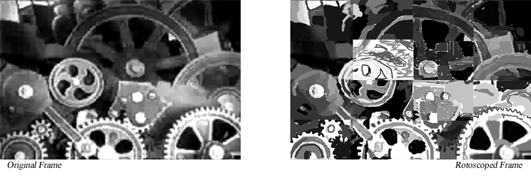
I found the study to work surprisingly well and was extremely impressed with the commitment of workers to spend substantial time and energy in the creation process for the reward of $.05. I enjoyed the rotoscoping project, and the connotations it suggests about the moral outcomes of distributed systems. I see it metaphorically relating to a plethora of issues resulting from bureaucratic processes, ranging from a lack of environmental responsibility, all the way to genocide. I intend to take this experiment further in the future, however, the results from this experiment began to drive my interests further towards the cultural and psychological ramifications of the system. Questions about the role of creativity and ownership, as well as motivations and self-worth became a higher priority. While I was satisfied with the initial results and enjoyed seeing the efforts that had been involved, I realized that the real enjoyment was in the analysis of the individual approach to creation, and that it was this factor that made the system truly compelling. It became clear that there was something more than the $.05 reward driving the efforts of these workers, and I want to bring that to light, as well as evoke questions about the ways such systems affect the creative drive, and the resulting satisfaction for the worker.

3.1.2. Sheep in Turk’s Clothing



The decision to request sheep drawings from the workers seemed immediately intriguing. After completing a few tasks through the system and feeling somewhat exploited, I was curious how workers would respond to the absurd task. When I saw the first sheep come through the system I knew I had made the right decision. As I had hoped, each sheep truly reflected the individual and humanity behind it. With the historical and social context of sheep, it seemed like the perfect metaphor and image in relation to the Mechanical Turk.

3.1.3. Presentation

Presentation of The Sheep Market took three forms.



The first 10,000 sheep were printed onto plate blocks of collectable stamps in the order that they were received. The stamps were grouped in blocks of twenty, a subtle reference to the traditional methods of counting sheep, which is a base-20 “score” system developed in the United Kingdom. With the enormity of this display I was hoping to initially overwhelm the viewer, but invite them to investigate the complexity at their own pace and discretion. From a distance, the patterns and details seemed very ordered and perhaps “important” in some way. That juxtaposition with the content of each drawing was very enjoyable. Equally pleasing, was the experience of watching viewers actively move about investigating all of the different sheep.
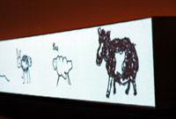

The second presentation was a conveyor-like system which drew the sheep onto the screen with the original stroke order used by the artist. This display echoed the assembly-line systems of the industrial age. The enormity of the database was presented through time and juxtaposed with the pace of the drawing process. The entire database was drawn about every six days, with sheep being constantly drawn and moved down the line. The humanity was perhaps best expressed through this display as the drawing process was clearly executed for the viewer to witness.

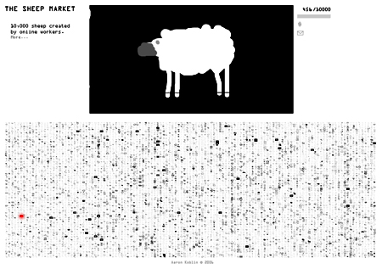

Finally, the sheep were presented online in a format that allowed viewing of the entire group as a whole, as well as browsing individual sheep and their creation process. Sheep can be sent and purchased through the website (www.TheSheepMarket.com). In some ways, this final incarnation of the project felt the most appropriate in dealing with the new online distributed technologies and issues. In an attempt to combine the features of the other display methods, all the sheep as well as their drawing processes are present and viewable, and the idea of commerce was re-introduced.

3.1.4. Selling sheep

The decision to sell or not to sell the sheep was one of the most difficult decisions of the project. It was important for me to address issues of ownership and individuality as related to commerce, but I was also aware of concerns about participating in the system as a whole, in contrast to subverting and commenting on it. Ultimately, I am satisfied with my decision to use the entire process as a commentary, including the sale of single edition sheep prints, because of the response from the community and from Amazon Web Services.

3.1.5. Response (Public Outcry)

Upon completion of the website the first to be notified were the workers themselves. The response was relatively hostile, but successful in that there seemed to be some dialog about the ramifications of the system. The first responses in a ‘Turker’ discussion thread titled “They’re selling our sheep!!!” included, “Does anyone remember signing over the rights to the drawings?” and “Someone should contact them and see how much they'd charge you to buy back the rights to one of your own sheep.” In addition to the workers, the Amazon Web Services Blog picked up the story and embraced The Sheep Market as an exemplary use of the Mechanical Turk system, Jeff from Amazon writes,
“You might look at this and think "What's the point?" or "how does this relate to my business?" Think of this as an example of how to quickly, easily, and inexpensively get 10,000 people to do something for you. Today it is sheep, but it could just as easily be choices of color combinations for car interiors, evaluation of some logos for your business, selection of most important features when choosing a vacation spot, and so forth.”

3.1.6. Shepherding

Developing the project was at least as enjoyable as experiencing the final results of the system. Along the way I monitored participation and analyzed the responses. The workers, who came predominantly from the United States, provided the following statistics.

Approximate collection rate | 11 sheep/hour
Collection period | 40 days
Rejected sheep | 662
Average Wage | $.69/hour
Time spent drawing (average/sheep) | 105 seconds
Unique IP addresses | 7599

Workers were allowed to draw up to 5 sheep to be submitted into the system. The majority drew one sheep and received $.02. There were a surprisingly low number of rebels who drew alternatives to sheep (about 30 depending on interpretation), and a similar number of workers who seemed to investigate the system and then abandon their task.

4. Art and Information
Recently, there have been a large number of art projects dealing directly with databases and statistical information, a trend which is perhaps not so surprising during the “information age.” There seem to be two major trends when dealing with data-art projects, however, those which deal with exposing the nature and intricacies of data, and those which are concerned with revealing something about the systems from which the data was collected.
In his article, The Anti-Sublime Ideal in Data Art, Professor Lev Manovich (UC San Diego) writes,
“If Romantic artists thought of certain phenomena and effects as un-representable, as something which goes beyond the limits of human senses and reason, data visualization artists aim at precisely the opposite: to map such phenomena into a representation whose scale is comparable to the scales of human perception and cognition.”

This notion of the data artist involves the task of rendering the incomprehensible comprehensible, or “anti-sublime.” This view of data art seems to follow the path of the scientific visualization or diagramming such as the work of Edward Tufte. By the end of his writing though, Manovich comes to the conclusion that,
“…rather than trying hard to pursue the anti-sublime ideal, data visualization artists should also not forget that art has the unique license to portray human subjectivity – including its fundamental new dimension of being “immersed in data.”

Following this prescription, I created a series of animations titled Flight Patterns, completed in 2005.


In contrast to the idea of creating an easily compressible visualization of the dense numerical data taken from air traffic controllers, the animations were an attempt at turning the data into something ephemeral and almost lucent that one could observe with a sense of intimacy simply not present in scientific visualization.

4.1. An Aesthetics of Governance

Warren Sack, a Professor in the Digital Arts New Media program at the University of California, Santa Cruz, presents an alternative look at the role of data visualization artist. In his paper “Aesthetics of Information Visualization,” Sack looks at examples of data art which attempt quite the opposite of the “anti-sublime.”

A project discussed by both theorists, John Simon’s Every Icon (1998), seems to present an opposing look at the anti-sublime, as posited by Warren Sack. The project, which algorithmically moves through each iteration of binary pixel adjustment, attempts to illustrate the seemingly infinite combinations of pixels which could be used to make a 32 x 32 icon. Through watching the animated process of enumeration, Sack argues that Simon actually seems to be presenting the sublime.
Opposed to the idea of the data artist as similar to the scientist or statistician, Sack presents a discussion of aesthetics of beauty, of the anti-sublime, of the sublime, of the uncanny and of administration, and ultimately argues that artists should perhaps be concerned with an aesthetics of governance.
“For by art is created that great Leviathan called a Commonwealth, or State (in Latin, Civitas), which is but an artificial man, though of greater stature and strength than the natural.”

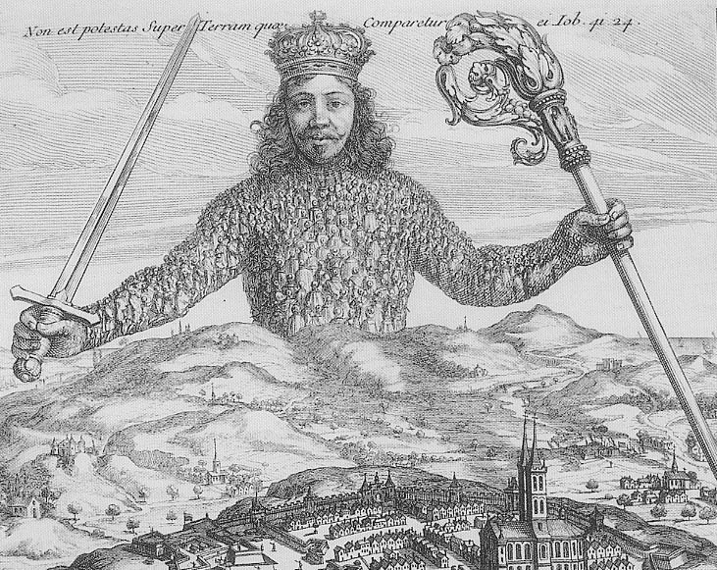
Sack’s aesthetics of governance concerns a “body politic” or “a Leviathan constituted from a group of people articulated together through a diverse set of social and technical means.” The Leviathan, as explained by Thomas Hobbes, is the ideological creature which results from a population beneath an authority. As a symbolic creature, the Leviathan has the body of the masses and the head of a central power, or single entity with ultimate control, a depiction not of the individual components or qualities of the system, but of the relationships and structures of the system itself. Sack writes,

“In the contemporary and the ancient world “art of governance” is not, and has not been, simply concerned with the perception of and representation of only things, or objects, but rather the interpretation, organization, articulation and representation of subjects, specifically the representation of people and things woven together.”

It is this contextualizing of information which is useful for generating stories, associations and positions, and is where, I would argue, a work can truly break from science towards a rich an intriguing artwork.

4.2. Data That Moves

The use of systems to organize and orchestrate, as well as comment is a practice already being implemented by some artists and organizations, both online and off. One artist, Antony Gormley, employs workers to execute a traditional sculpture process for the creation of thousands of individual human figurines. His terracotta figures are created with general guidelines and processes which ensure that they conform to a standard, but it is exactly the deviation from perfection and human quality shining through, which makes the work truly successful.
Antony Gormley, Field


The involvement of human workers is taken even further in the work of Santiago Sierra which consists of employing individuals to perform tasks which illustrate the “uselessness” of capitalism. His piece, Line, involves paying $30 to each of six men to receive a tattoo of a line across their backs. Other works include Lifted Out Wall Leaning Over by 60 Degrees and Held Up by 5 People, and Buried alive, which also involve hiring people to do absurd and questionable acts with the intention of raising questions.
Santiago Sierra, Line

Online, there are several projects which use systems of creation as a self-referential commentary. Work such as Glyphiti by Artcontext.net, which was started by American artist Andy Deck, involves an open canvas where the community is constantly evolving the online image. In the project, the individual pixels can be adjusted freely by anyone who chooses to do so. The canvas can be seen as a battle ground for territory, as well as a community which dictates evolution and expresses respect. The project imitates in some ways the occurrences on many graffiti walls in urban spaces.

Artcontext.net, Glyphiti
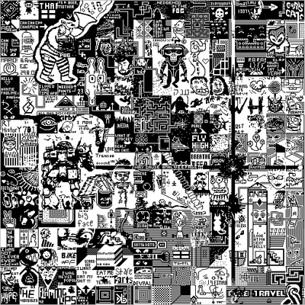

Another experimental project, OpenStudio, at MIT’s media lab, establishes an entire economy based off the buying and selling of artwork created in the online closed system. The project is an interesting investigation into the effects of free market on cultural objects, the site deals with issues of appropriation and sampling, as well as reputation and trade-value.
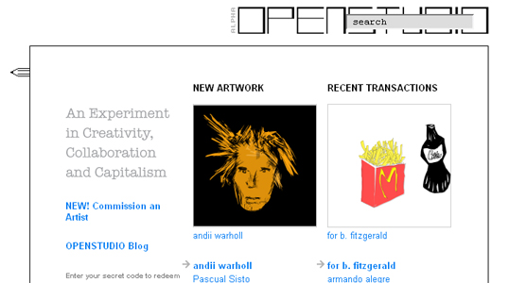
5. Conclusion

This month, June 2006, Wired magazine ran a featured article titled “The Rise of Crowdsourcing.” The term, coined by Jeff Howe refers to the emerging distributed systems which utilize “the new pool of cheap labor: everyday people.” In the article, Howe outlines a few such systems, including Amazon’s Mechanical Turk, used for R&D, entertainment, and cataloging. The article illustrates the dramatic effects of such systems in an already competitive marketplace. The first example is the story of a stock photographer forced out of business by the increasingly popular iStockPhoto.com, which allows thousands of submissions from amateurs with increasingly sophisticated consumer products. The article continues with numerous examples illustrating the similarities between crowdsourcing and outsourcing, specifically, a decreased cost to the employer, and often a decreased quality for the consumer. The article ends with the following example from one company using Amazon’s Mechanical Turk for development;

“Gupta turns his laptop around to show me a flowchart on his screen. ‘This is what we were paying $2,000 for. But this one,’ he says, ‘was authored by one of our Turkers.’ I ask how much he paid. His answer: ‘Five dollars.’”

The effects of such systems in the global marketplace remain to be seen, however with such substantial changes in costs and profit margins, the widening of the class gap seems likely. As of June 2005, one-tenth of one percent of the world’s population controlled one-quarter of the world’s assets, and half of the planet’s population lived on less than two dollars per day. This financial distribution, coupled with the structure of such distributed employment systems seems likely to only further progress this polarized trajectory.
Some, however, argue that new online labor systems may in fact have the opposite effect. The first argument is that services such as the Mechanical Turk allow not only large corporations access to a large distributed work force, but individuals and small businesses as well. This point is worth consideration, and is certainly what I have been exploring. However, when analyzed in context of the marketplace, issues such as the digital divide and the technological barriers involved in development seem quite serious, as it is currently necessary to have at least a basic understanding of computer programming, not to mention access to a computer and internet connection in order to get started using the service.
The second argument for the benefits of such systems is the potential for growth in international marketplaces. Tony Herrera, a worker’s compensation specialist in Los Angeles, who works with low-skilled, low-wage workers, is optimistic that such systems “could be harnessed and used in Mexico and Central America as an income generator for unemployed and underemployed citizens.” While I agree that there could be some isolated improvements in certain regions, the long term position of such systems would seem to me to more closely echo the current maquiladoras already being implemented in Mexico, where external influences exploit the cheap labor for re-exported production. Such systems notably add no products to local economies, damage local production and culture, and take no responsibility for worker’s living and working conditions. These factors combined with a more extreme digital divide suggest that such systems may not provide a real assistance to the global economy.

“The one small garden of a free gardener was all his need and due, not a garden swollen to a realm; his own hands to use, not the hands of others to command.”

J.R.R. Tolkien’s stories seem to represent the distributist ideal to an extreme. In his novels, the fictional world of ‘middle-earth’ is comprised of a duality, the ‘hobbit-sense’ of the Shire, and the dark industrialism of Mordor. In the Shire, hobbits are each creators and controllers of their own production. Through community, individual craftsmen and farmers produce goods to sustain the society. Online, services such as Craigslist, Del.icio.us, Flikr, and even eBay seem in some ways to echo this theme.
As technologies are constructed and integrated into social frameworks, there should be a conscious consideration for the ramifications and side-effects of their orchestration. While massive bureaucratized systems with heavily imbalanced relations of power are often extremely productive and speedy, they usually come with drawbacks, and are not the only option when it comes to production. The open-source system is a great example of a viable alternative, where hundreds of applications created by volunteer workers are able to compete (and occasionally out perform) competitive corporate-developed software. By embracing individual worth and contribution, open-source projects lead to the creation of viable software which is guided by the needs of its users and which carry accompanying vibrant communities of proud contributors.
After forty days of collecting sheep I shut down the sheep drawing application and discontinued the worker requests. However, since the launching of the project site I have begun to receive hand drawn sheep and requests to add new sheep to the lot. The presumption that workers were being driven by something more than money seems to be officially verified. Although I believe the motives are different after understanding the project, the fact that people go out of their way to create sheep truly inspires, intrigues, and perhaps somewhat disturbs me. It is my hope that the viewers of the project are both entertained and caught off guard in such a way that forces questioning, and hints at the ideas I’ve discussed.

Moving Units, Dangerous Dreams (CD) - Palm Pictures - 2004
Business Week – “The Tech Beat : Amazon’s Mechanical Turk” – Nov. 4 2005 http://www.businessweek.com/the_thread/techbeat/archives/2005/11/amazons_mechani.html
Mechanical Turk FAQ http://www.mturk.com/mturk/help?helpPage=whatis
Standage, Tom. The Life and Times of The Famous Eighteenth-Century Chess Playing Machine. Walker Publishing Company, Inc. New York. 2002.
Orwell, George. Animal Farm. Signet Classics; 50th Anniv Edition 2004
Deffinbaudh, Bob. Th. M. “The Good Shepherd and the Flock of God.” Bible.org 2005
John 10:11-18 (New King James Version)
http://en.wikipedia.org/wiki/Image:Dolly_the_sheep2-thumb.jpg
http://news.bbc.co.uk/onthisday/hi/dates/stories/february/22/newsid_4245000/4245877.stm
Turner, John R.G. “Why was the world so unprepared for Dolly, the cloned sheep?” NY Times Dec. 28 1997
Howard, Richard and Antoine de Saint-Exupéry , The Little Prince. Harvest Books; 2000
BBC.co.uk – “Historic Fiures: Robert Bakewell” http://www.bbc.co.uk/history/historic_figures/bakewell_robert.shtml
Overton, Mark: “Agricultural Revolution in England 1500 – 1850” BBCi History: 19-09-2002
Landes, David S. The Unbound Prometheus : Technical Change and Industrial Development in Western Europe from 1750 to the Present 2nd ed. New York : Cambridge University Press, 2003 (pg. 44-46)
Bulback, Stanlet. “The Importance of Wool.” Oriental Rug Review, Vol. 8/3, February/March, 1998
http://www.archives.gov/education/lessons/cotton-gin-patent/
Chow, We-Min. Assembly Line Design. 1990 - USA: IBM Corporation
Ollman, Bertell. Alienation: Marx's Conception of Man in Capitalist Society Cambridge U.P., l97l
Pappenheim, Fritz. “Alienation in American Society.” Monthly Review. Volume 52, Number 2
Lazzarato, Maurizio. “European Cultural Tradition and the New Forms of Production and Circulation of Knowledge.” Translated by Bram Dov Abramson (bram@tao.ca)
Chesterson, G.K. The Uses of Diversity Dodd, Mead and Co. New York 1921
“Big Blue Beats Kasparov.” - http://www.research.ibm.com/deepblue/home/html/b.html
Kurzweil, Raymond. “The Law of Accelerating Returns.” KurzweilAI.net March 7, 2001
Diamond, Jared. Guns, Germs, and Steel: The Fates of Human Societies. W.W. Norton & Company 1999
Turker Nation – “They’re selling our sheep!” http://turkers.proboards80.com/index.cgi?board=general&action=display&thread=1146827374&page=1
Amazon Web Services Blog (May 10th 2006) http://aws.typepad.com/aws/2006/05/10000_sheep_col.html
Manovich, Lev. “The Anti-Sublime in Data Art.” (2002) http://www.manovich.net/DOCS/data_art.doc
Sack, Warren. “Aesthetics of Information Visualization.” to appear in Context Providers, Christiane Paul, Victoria Vesna, and Margot Lovejoy, Editors (forthcoming)
Hobbes, Thomas. Introduction, Leviathan (1651).
http://www.corriere.it/Hermes%20Foto/2003/07_Luglio/23/STATUE--550x342.jpg
http://www.emaf.de/_emaf/typo3temp/18fd839ce8.jpg
http://artcontext.net/glyphiti/
http://openstudio.media.mit.edu
Howe, Jeff. “The Rise of Crowdsourcing.” Wired Magazine 14.06. June 2006.
http://www.globalissues.org/TradeRelated/Facts.asp
http://tonyherrera.blogspot.com/2006/05/help-wanted-will-pay-069-per-hour.html
Tolkien, J.R.R. The Return of the King Houghton Mifflin (Reprint June 1, 2005)

